ITEM DETAILS
Name of Item | Inter-War Flats
Other Name/s  Former Name/s | 2B Penkivil Street, Bondi
Item type | Built
Item group | Flat Building
Item category | Flat
Area, Group, or Collection Name | Unknown
Street number | 2B
Street name | Penkivil Street
Suburb/town | Bondi |  |  |  |  | Postcode |  |  | 2026
Local Government Area/s | Waverley
Property description | SP 10884
Location - Lat/long | Latitude | -33.888923 |  | Longitude | 151.262329
Location - AMG (if no street address) | Zone |  |  | Easting |  |  |  | Northing
Owner | Private
Current use | Residential
Former Use | Residential
Statement of significance | 2B Penkivil Street, Bondi (c1936) is a fine example of a four and five-storey Inter-War Art Deco flat building in a suburban setting, that is outstanding in its precinct due to its scale, style and group value. It represents the development of Inter-War flat buildings, an important phase in the history of Waverley which represents the 1920s-1930s development boom, a prominent period of economic prosperity and speculative development in Waverley associated with the changing demographics with a shift to living in flats. It has historic association with architect Eric Pitt and the Brasch family, who developed their former residence as a speculative development. It is also a rare local example of a flat building that was targeted to a prosperous demographic, as evidenced in the spacious penthouse apartments, elevator, and basement carpark.
Level of Significance | National |  | State |  |  |  | Local

DESCRIPTION
Designer

Builder/ maker

Physical Description | 2B Penkivil Street, Bondi, Roland Gardens, is a four- and five-storey flat building that dates from the Inter-War period (c1936), a key period of significance of the Bondi area. The building displays features of the Inter-War Art Deco style including symmetrical form, stepped building mass, stepped parapet, decorative face brickwork, parallel line motifs, horizontal banding, and vertical fins. The building is set back 4 metres from the street on an irregular, L-shaped site approximately 20 metres wide that has been subdivided in a suburban strip setting that has retained some of its historic context. The site overlooked Schneider’s Garden (now Thomas Hogan Reserve). The site has a fence of face brick with decorative brick piers approximately 1 metre high, which compliments the setting of the place and a side driveway accessing a basement carpark which dates from the c1936 period. The site is large and informally landscaped, and features concrete paths, mature trees and hedging and provides an appropriate landscaped setting for the building. The plan layout features 3 flats per floor with side entry (Flat Type 5 – Inter-War study) and a penthouse apartment. The building is in excellent condition and is highly intact.  Elements impacting upon the integrity of the site include security bars to the windows.
Physical condition  and  Archaeological potential | The building appears to be in good condition.
Construction years | Start year | 1930 | Finish year | 1986 | Circa
Modifications and dates

HISTORY
Historical notes | 2B Penkivil Street, Bondi formed part of the early Mamhead estate and was built on a street named after George Penkivil Slade. The land was owned by Edward Flood and J. B. Jones, who had previously bought two 10-acre portions on Bondi Road. They also purchased 14 acres for £210, between Anglesea Street and Penkivil Street, extending north to Old South Head Road. The grant was issued on February 27, 1839. This land was subdivided before 1885 by J. Newman, of Mamhead Lodge. A portion of the south end of the early subdivision between Penkivil and Anglesea streets and Bondi Road became Slade's subdivision about the 1880s. (Draft Waverley Heritage Assessment).  The 1891 Detail Survey shows the land developed with a large semi-detached Victorian Villa. Henry Moss Brasch was the son of Woolfe Brasch of ‘Athens’ No 4 Penkivil Street Bondi. The family was engaged in the clothing manufacturing business (Hebrew Standard 2 Nov 1990, p7). His brother, Reuben David Brasch, established a successful clothing store in Oxford Street, Hyde Park corner, and was known for his charitable works. Reuben died in 1932, leaving half of his substantial estate to Henry. The plans to develop land in Penkivil Street followed in 1936. Plans for the flat building were prepared by Eric C Pitt architect for H.M Brasch Esq in 1936. The plans provided for 3 flats per floor on the first 3 levels, and spacious penthouse apartments comprising 3 bedrooms and 2 maid rooms which was unusual for Inter-War flats in Waverley. Also unusual was basement carparking and elevator.

THEMES
 | National historical theme | 4 Building settlements, towns and cities  8 Developing Australia’s Cultural Life  9 Marking the phases of life
 | State  historical theme | Accommodation  Domestic life  Creative endeavour  Persons
 | Local  historical theme | Flats and Bungalows  Speculation and Subdivision

Assessment
A: Historical Significance | 2B Penkivil Street, Roland Gardens, has historical significance at a local level as it represents the development of Inter-War flat buildings, an important phase in the history of Waverley which represents the 1920s-1930s development boom, a prominent period of economic prosperity and speculative development in Waverley associated with the changing demographics with a shift to living in flats.
B: Associative | 2B Penkivil Street, Bondi has historical association significance at a local level as it is associated with architect Eric Pitt and the Brasch family, who developed their former residence as a speculative development.
C: Aesthetic significance | 2B Penkivil Street, Bondi has aesthetic significance at a local level as a fine example of a four and five-storey Inter-War Art Deco flat building in a suburban setting, that is outstanding in its precinct due to its scale, style and group value. The building shows an accomplished use of Inter-War Art Deco style which features symmetrical form, stepped building mass, stepped parapet, decorative face brickwork, parallel line motifs, horizontal banding, and vertical fins. The penthouse apartment, elevator, and basement carpark are unusual features for Inter-War flats in Waverley.
D: Social significance | To date no social, cultural, and spiritual significance has been identified.
e) Technical/  Research significance | To date no technical significance has been identified.
f) Rarity | 2B Penkivil Street, Bondi has rarity significance at a local level as it is a rare local example of a flat building that was targeted to a prosperous demographic, as evidenced in the spacious penthouse apartments, elevator, and basement carpark. These features are unusual for Inter-War flats in Waverley despite being well represented in other local government areas.
g) Representative-ness | 2B Penkivil Street, Bondi has representative significance at a local level as a fine example of a four and five-storey Inter-War Art Deco flat building in a suburban setting, that is outstanding in its precinct.
Integrity | The building is highly intact.

HERITAGE LISTINGS
Heritage listing/s | Draft Waverley LEP 2012

INFORMATION SOURCES
Type | Author/Client | Title | Year | Repository
 | Waverley Council | Waverley Heritage Policy | 2007
 | Waverley Council | Waverley Heritage Study | 1993
 | Perumal Murphy Pty Ltd | Waverley Heritage Study | 1990
 |  | Hebrew Standard 2 Nov 1990, p7 | 1990

RECOMMENDATIONS
Recommendations

SOURCE OF THIS INFORMATION
Name of study or report | Heritage Policy by Waverley Council reviewed by Architectural Projects 2023 |  | Year of study or report
Item number in study or report

Author of study or report
Inspected by
NSW Heritage Manual guidelines used? |  |  |  | Yes |  | No
This form completed by |  |  |  | Date

IMAGES

Image caption | 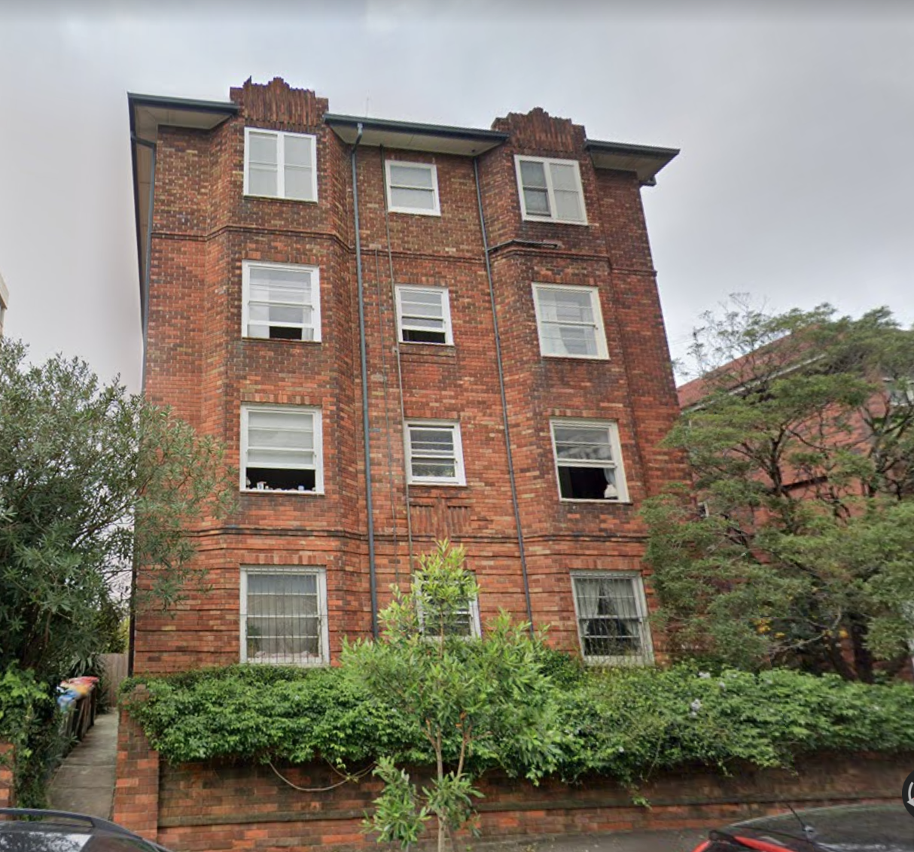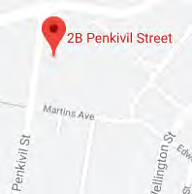
Image year |  | Image by | Google Maps | Image copyright holder

Image caption | 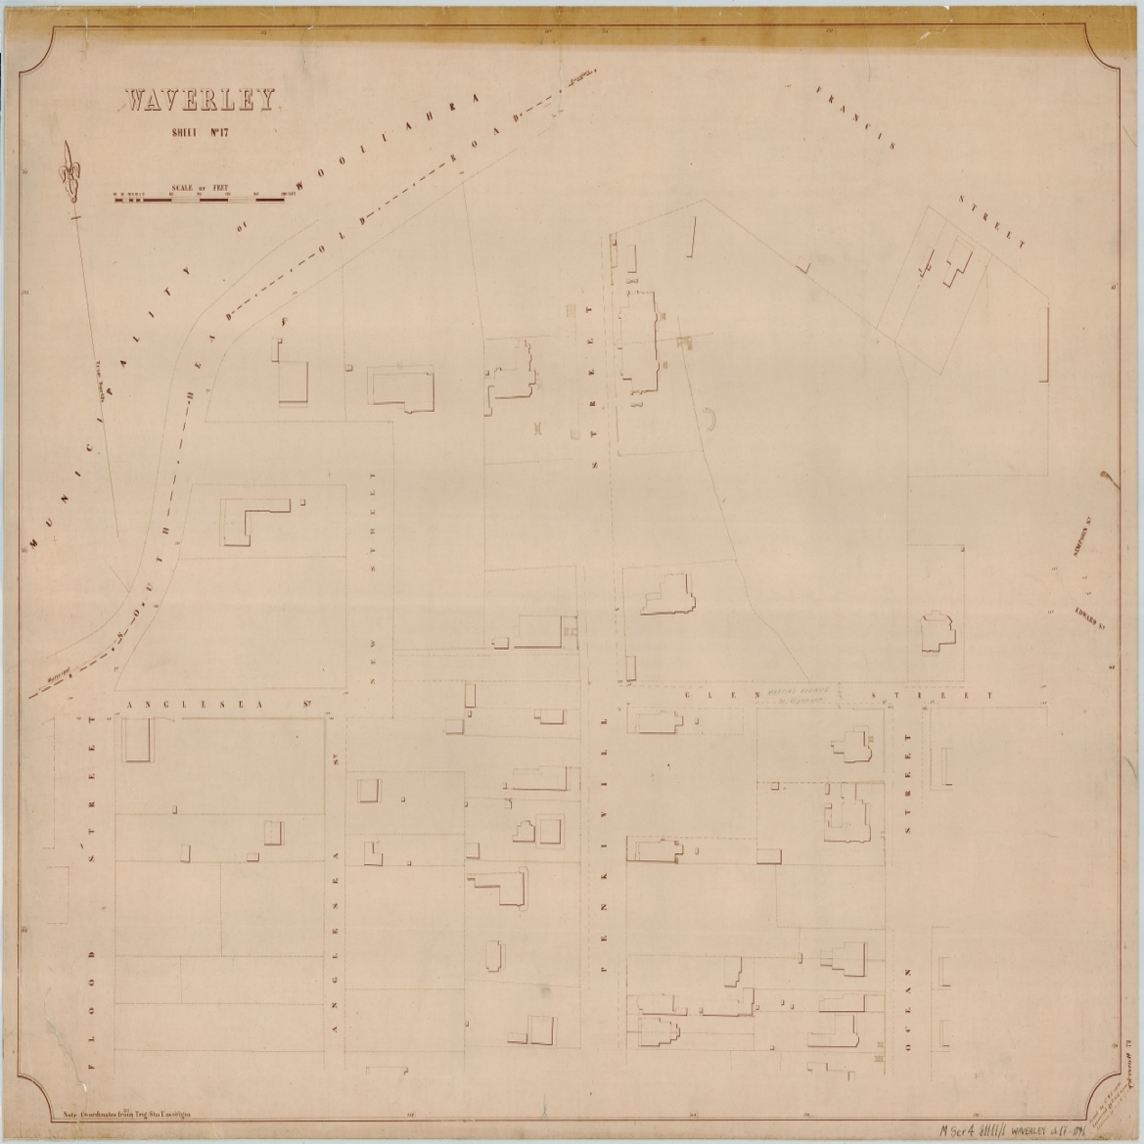
Image year | 1891 | Image by | State Library of New South Wales | Image copyright holder

Image caption | 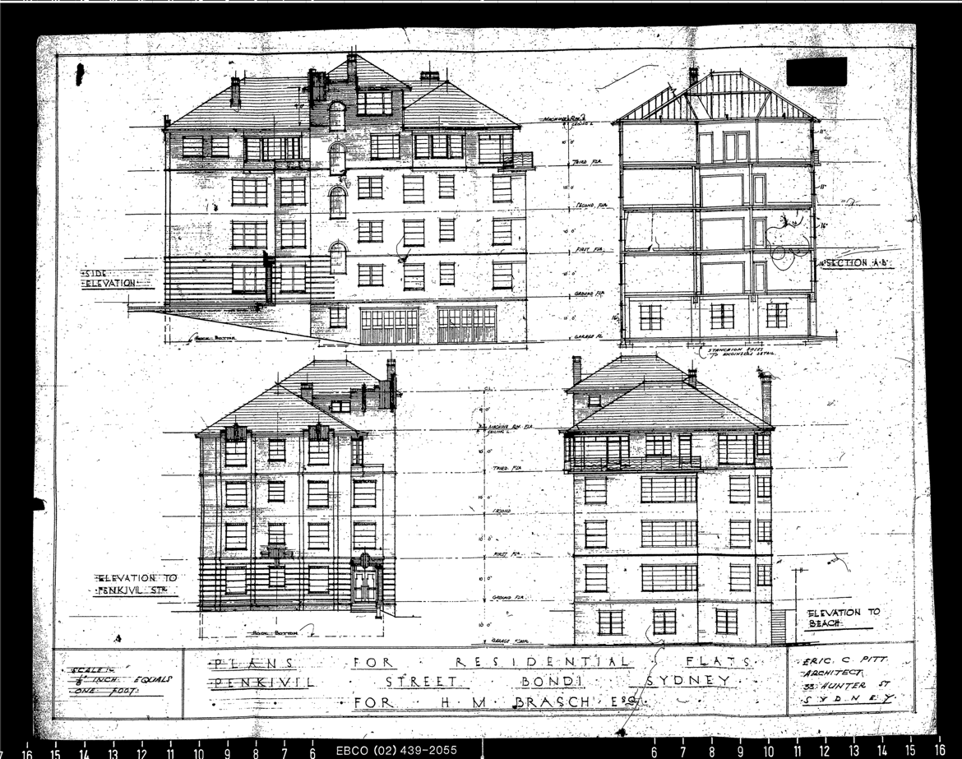
Image year | 1936 | Image by | Waverley Council | Image copyright holder

Image caption

Image year | 1936 | Image by | Waverley Council | Image copyright holder

Image caption | 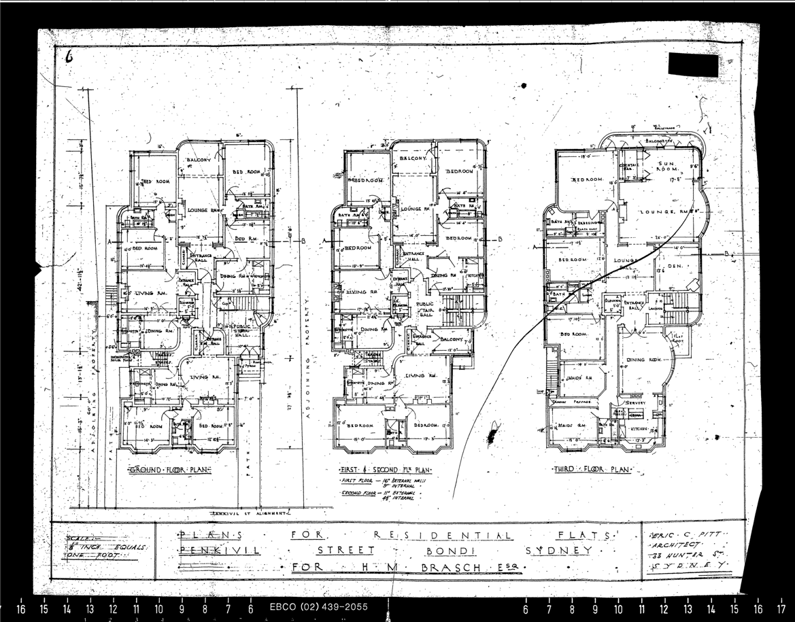
Image year | 1936 | Image by | Waverley Council | Image copyright holder

Image caption | 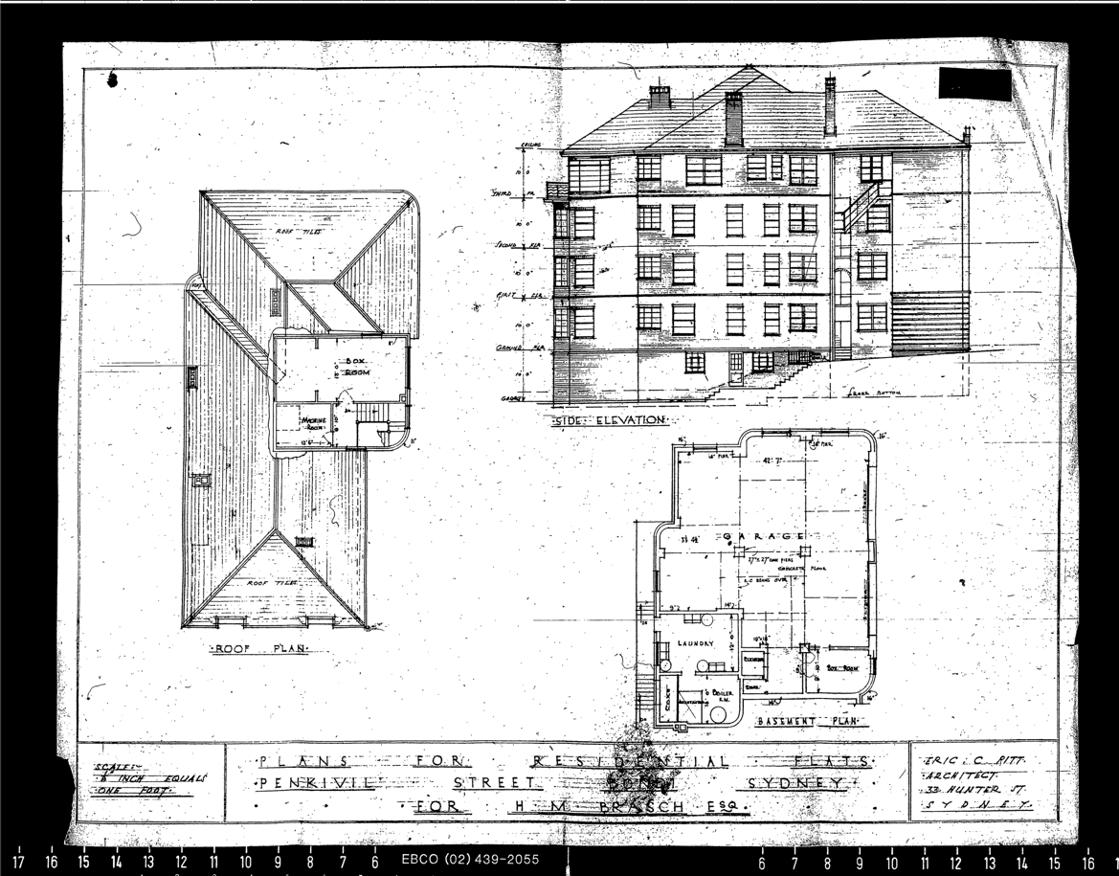
Image year | 1936 | Image by | Waverley Council | Image copyright holder

